Chapter 19, Problem 47.

Obtain the ABCD parameters for the network in Fig. 19.102.

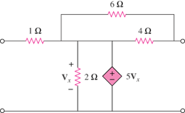

Figure 19.102
For Prob. 19.47.

